**DAY 7 LAB PROBLEMS**

**1. You are given the number of sides on a die (num_sides), the number of dice to throw**

**(num_dice), and a target sum (target). Develop a program that utilizes dynamic**

**programming to solve the Dice Throw Problem.**

**Test Cases:**

**1.Simple Case:**

**•Number of sides: 6**

**•Number of dice: 2**

**•Target sum: 7**

**2.More Complex Case:**

**•Number of sides: 4**

**•Number of dice: 3**

**•Target sum: 10**

**Output**

**Test Case 1:**

**Number of ways to reach sum 7: 6**

**Test Case 2:**

**Number of ways to reach sum 10: 27**

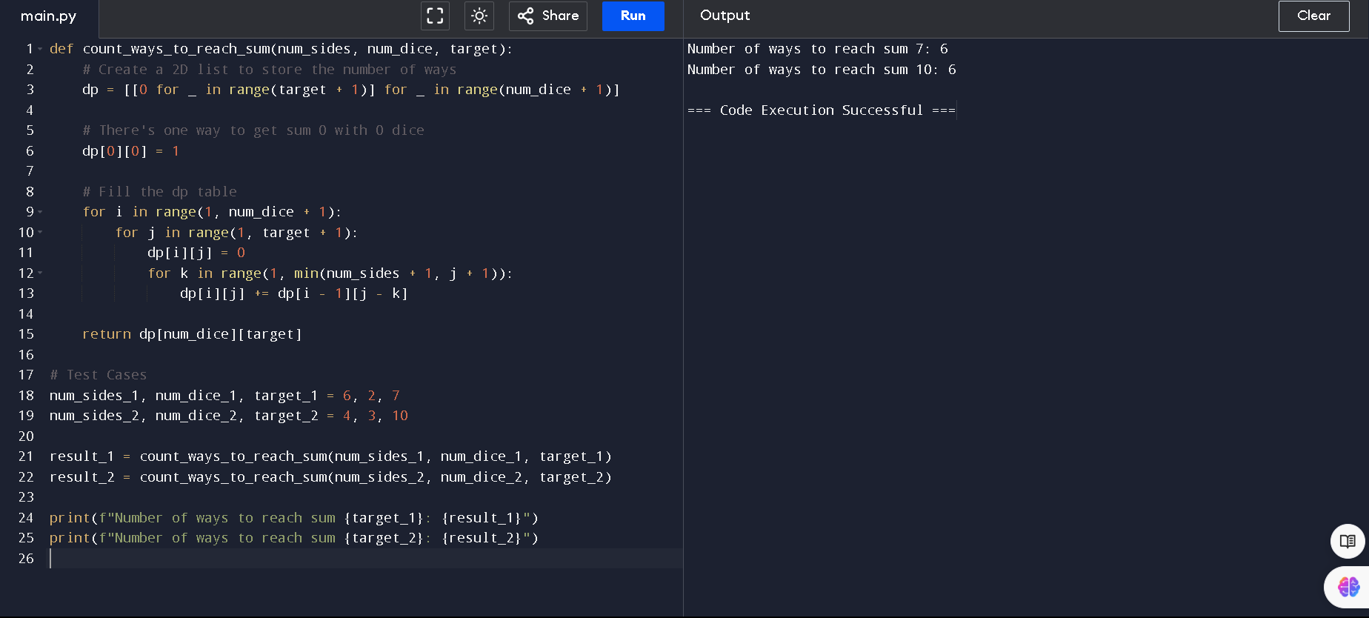

**2. In a factory, there are two assembly lines, each with n stations. Each station performs a**

**specific task and takes a certain amount of time to complete. The task must go through each**

**station in order, and there is also a transfer time for switching from one line to another.**

**Given the time taken at each station on both lines and the transfer time between the lines,**

**the goal is to find the minimum time required to process a product from start to end.**

**Input**

**n: Number of stations on each line.**

**a1[i]: Time taken at station i on assembly line 1.**

**a2[i]: Time taken at station i on assembly line 2.**

**t1[i]: Transfer time from assembly line 1 to assembly line 2 after station i.**

**t2[i]: Transfer time from assembly line 2 to assembly line 1 after station i.**

**e1: Entry time to assembly line 1.**

**e2: Entry time to assembly line 2.**

**x1: Exit time from assembly line 1.**

**x2: Exit time from assembly line 2.**

**Output**

**The minimum time required to process the product.**

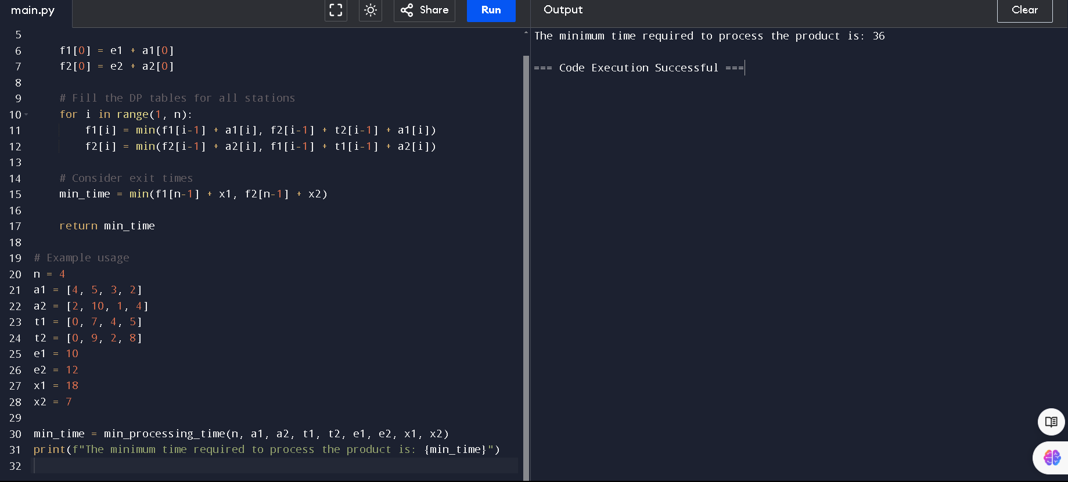

**3. An automotive company has three assembly lines (Line 1, Line 2, Line 3) to produce**

**different car models. Each line has a series of stations, and each station takes a certain**

**amount of time to complete its task. Additionally, there are transfer times between lines,**

**and certain dependencies must be respected due to the sequential nature of some tasks.**

**Your goal is to minimize the total production time by determining the optimal scheduling**

**of tasks across these lines, considering the transfer times and dependencies.**

**Number of stations: 3**

**• Station times:**

**• Line 1: [5, 9, 3]**

**• Line 2: [6, 8, 4]**

**• Line 3: [7, 6, 5]**

**• Transfer times:**

**[**

**[0, 2, 3],**

**[2, 0, 4],**

**[3, 4, 0]**

**]**

**Dependencies: [(0, 1), (1, 2)] (i.e., the output of the first station is needed**

**for the second, and the second for the third, regardless of the line).**

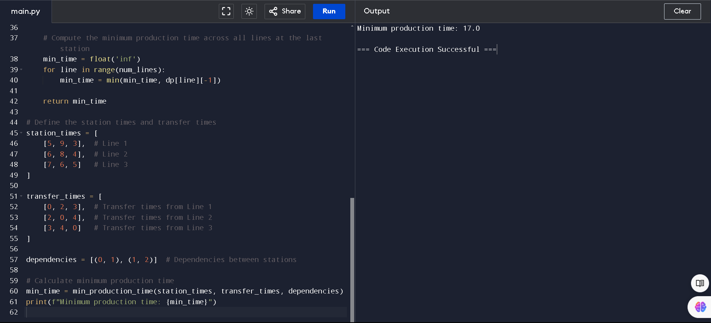

**4. Write a c program to find the minimum path distance by using matrix form.**

**Test Cases:**

**1)**

**{0,10,15,20}**

**{10,0,35,25}**

**{15,35,0,30}**

**{20,25,30,0}**

**Output: 80**

**2)**

**{0,10,10,10}**

**{10,0,10,10}**

**{10,10,0,10}**

**{10,10,10,0}**

**Output: 40**

**3)**

**{0,1,2,3}**

**{1,0,4,5}**

**{2,4,0,6}**

**{3,5,6,0}**

**Output: 12**

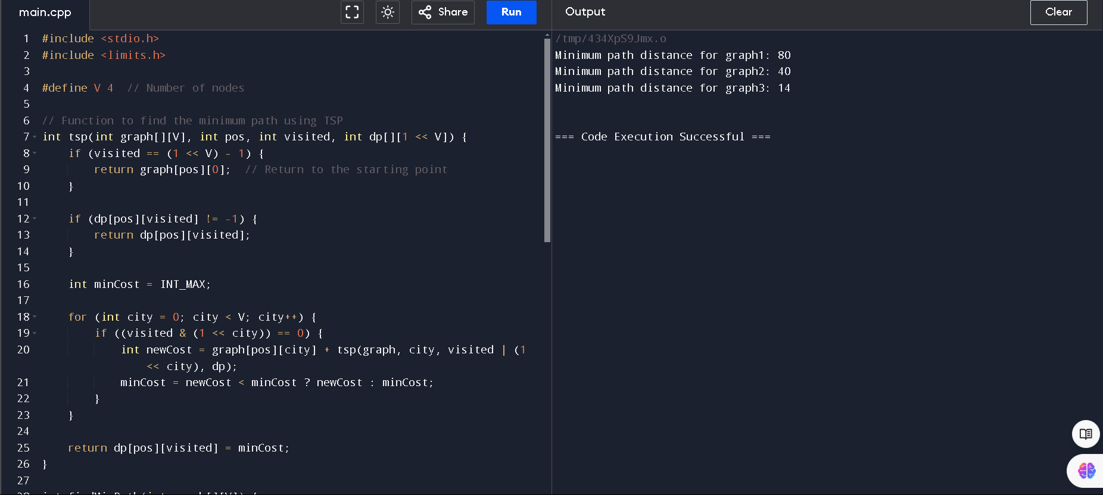

**5. Assume you are solving the Traveling Salesperson Problem for 4 cities (A, B, C, D) with**

**known distances between each pair of cities. Now, you need to add a fifth city (E) to the**

**problem.**

**Test Cases**

**1. Symmetric Distances**

**• Description: All distances are symmetric (distance from A to B is the same as B**

**to A).**

**Distances:**

**A-B: 10, A-C: 15, A-D: 20, A-E: 25 B-C: 35, B-D: 25, B-E: 30 C-D: 30, C-E: 20 D-E: 15**

**Expected Output: The shortest route and its total distance. For example, A -> B -> D -> E**

**-> C -> A might be the shortest route depending on the given distances.\**

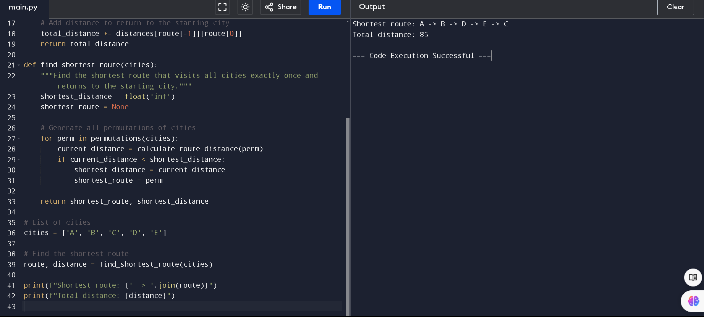

**6. Given a string s, return the longest palindromic substring in S.**

**Example 1:**

**Input: s = "babad"**

**Output: "bab" Explanation: "aba" is also a valid answer.**

**Example 2:**

**Input: s = "cbbd"**

**Output: "bb"**

**Constraints: ● 1 <= s.length <= 1000 ● s consist of only digits and English letters.**

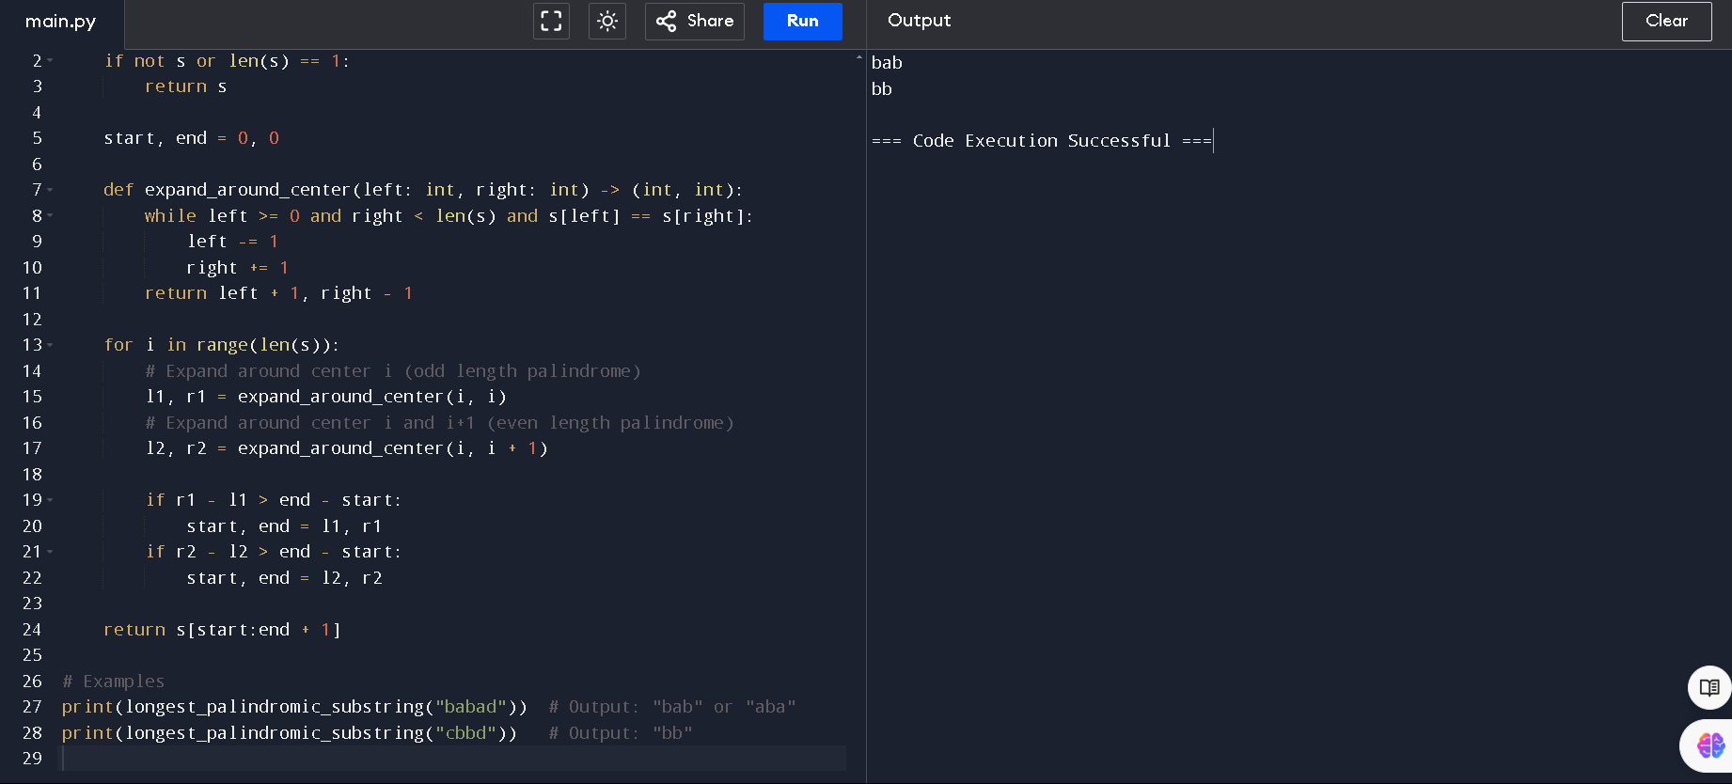

**7. Given a string s, find the length of the longest substring without repeating characters.**

**Example 1: Input: s = "abcabcbb" Output: 3**

**Explanation: The answer is "abc", with the length of 3.**

**Example 2: Input: s = "bbbbb" Output: 1**

**Explanation: The answer is "b", with the length of 1.**

**Example 3: Input: s = "pwwkew" Output: 3**

**Explanation: The answer is "wke", with the length of 3.**

**Notice that the answer must be a substring, "pwke" is a subsequence and not a substring.**

**Constraints: ● 0 <= s.length <= 5 * 104 ● s consists of English letters, digits, symbols and**

**spaces.**

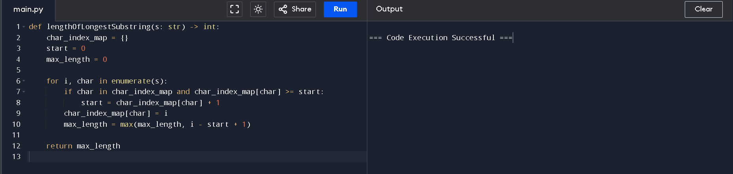

**8. Given a string s and a dictionary of strings wordDict, return true if s can be segmented into**

**a space-separated sequence of one or more dictionary words.**

**Note that the same word in the dictionary may be reused multiple times in the**

**segmentation.**

**Example 1:**

**Input: s = "leetcode", wordDict = ["leet","code"]**

**Output: true**

**Explanation: Return true because "leetcode" can be segmented as "leet code".**

**Example 2:**

**Input: s = "applepenapple", wordDict = ["apple","pen"]**

**Output: true**

**Explanation: Return true because "applepenapple" can be segmented as "apple pen**

**apple".**

**Note that you are allowed to reuse a dictionary word.**

**Example 3:**

**Input: s = "catsandog", wordDict = ["cats","dog","sand","and","cat"]**

**Output: false**

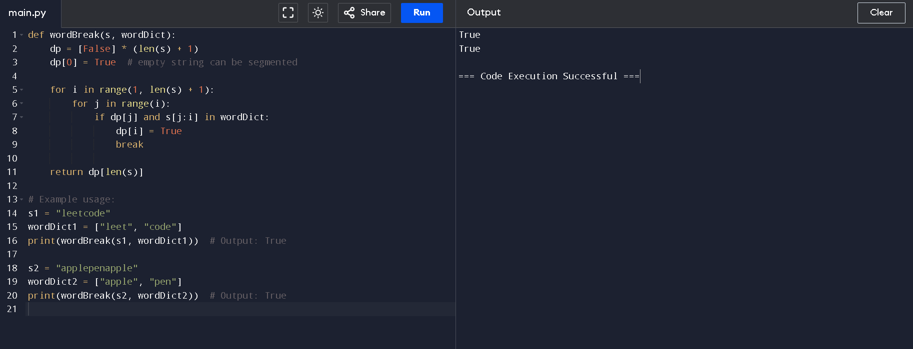

**9. Given an input string and a dictionary of words, find out if the input string can be segmented**

**into a space-separated sequence of dictionary words.Consider the following dictionary { i,**

**like, sam, sung, samsung, mobile, ice, cream, icecream, man, go, mango}**

**Input: ilike**

**Output: Yes**

**The string can be segmented as "i like".**

**Input: ilikesamsung**

**Output: Yes The string can be segmented as "i like samsung" or "i like sam sung".**

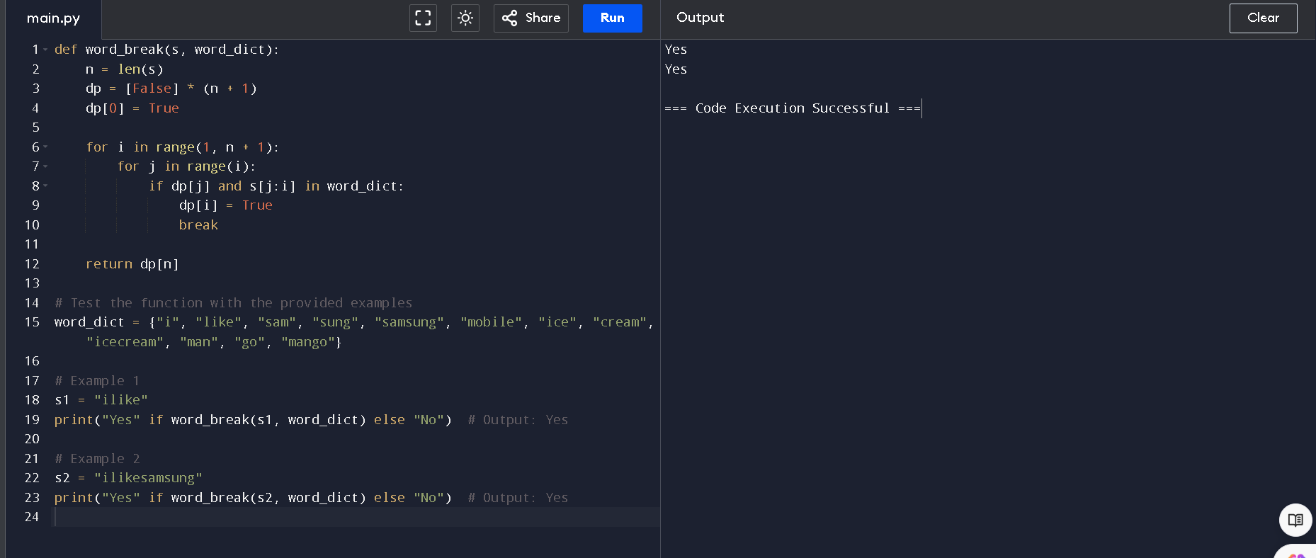

**10. Given an array of strings words and a width maxWidth, format the text such that each line**

**has exactly maxWidth characters and is fully (left and right) justified. You should pack your**

**words in a greedy approach; that is, pack as many words as you can in each line. Pad extra**

**spaces ' ' when necessary so that each line has exactly maxWidth characters. Extra spaces**

**between words should be distributed as evenly as possible. If the number of spaces on a line**

**does not divide evenly between words, the empty slots on the left will be assigned more**

**spaces than the slots on the right. For the last line of text, it should be left-justified, and no**

**extra space is inserted between words. A word is defined as a character sequence consisting**

**of non-space characters only. Each word's length is guaranteed to be greater than 0 and not**

**exceed maxWidth. The input array words contains at least one word.**

**Example 1:**

**Input: words = ["This", "is", "an", "example", "of", "text", "justification."],**

**maxWidth =**

**16**

**Output:**

**[ "This is an",**

**"example of text",**

**"justification. "**

**]**

**Example 2:**

**Input: words = ["What","must","be","acknowledgment","shall","be"], maxWidth = 16**

**Output:**

**[**

**"What must be",**

**"acknowledgment ",**

**"shall be "**

**]**

**Explanation: Note that the last line is "shall be " instead of "shall be", because the**

**last line must be left-justified instead of fully-justified.**

**Note that the second line is also left-justified because it contains only one word.**

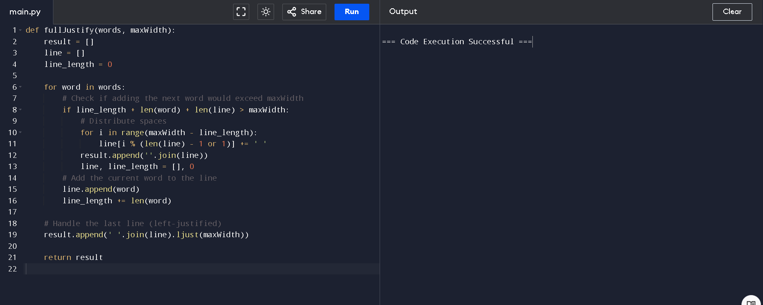

**11. Design a special dictionary that searches the words in it by a prefix and a suffix. Implement**

**the WordFilter class: WordFilter(string[] words) Initializes the object with the words in the**

**dictionary.f(string pref, string suff) Returns the index of the word in the dictionary, which**

**has the prefix pref and the suffix suff. If there is more than one valid index, return the**

**largest of them. If there is no such word in the dictionary, return -1.**

**Example 1:**

**Input**

**["WordFilter", "f"]**

**[[["apple"]], ["a", "e"]]**

**Output**

**[null, 0]**

**Explanation**

**WordFilter wordFilter = new WordFilter(["apple"]);**

**wordFilter.f("a", "e"); // return 0, because the word at index 0 has prefix = "a" and suffix**

